**FOSS   
(FedEx Open Source Software)**

How to navigate the FOSS site,   
create a request for software,  
and   
Frequently Asked Questions



Anyone requesting and using OpenSource Software (OSS) for use within FedEx must read the [**Business Process Standard**](https://esso.secure.fedex.com/pex/foss/bps.doc)document and agree to the Requirements, Applicability and understand the License Categorizations and how they will be used with the specific software requested/used. This includes the requester and any additional users of that software.

The FOSS site is divided into three screens: **myFOSS** which will display download link(s) for software you’ve been approved for; **Request Product** where you can search for products that have already been evaluated and are either approved for usage (depending security zone and/or use case), or have been rejected by the company for a litany of reasons and are not available (or are awaiting the process) and links to request new software not found on the list; and **Documentation** where you can find helpful links for documents, the FOSS eye chart, Business Process Standard (BPS) document, Sonatype User Guide and support help.

Software approval relies not just on the base request but what security zones the application will be used in, use case, and which license governs the software. Some license entities are not allowed at FedEx. There are requirements that apply when creating a request including reading the FOSS “Business Process Standard” which outlines all requirements - legal and otherwise – that you must be adhered to when applying for software, installing the software and using it. This document is very detailed on what constitutes a zone, which licensing bodies supply OSS for use, and pertinent information that you – as a requestor and user – must understand and agree to.

Understanding your ‘zone’ and how the license can or cannot be used in that zone is paramount to creating a request; detailed zone descriptions are available in the [Business Process Standard](https://esso.secure.fedex.com/pex/foss/bps.doc) document and FOSS eye chart and should be read and understood before you create any request.

All software requests require a form to be filled out and submitted, whether for existing software already in FOSS or a new product. A new product request is a 2-step process; using Sonatype to get a detailed evaluation of your software, and using that data to complete the request form.

The process of how requests are created and how the reviews are done is important to understand; the fields within the request form are required and any field that is not populated or does not “make sense” dependent on other fields will be rejected and will need to be revised in order to be processed.

All new requests will need to go through the Architectural Council approval meeting held weekly before they appear on your myFOSS page. Additional approval may be required and may have to go to Legal based on licensing, zones and use case which may take longer. New software requests can be a lengthy process and take months to even get to Legal as they are reviewed and approved quarterly only and a limited number are reviewed each time.

**NOTE**: Knowingly misrepresenting or omitting information on the form in order to get software approved jeopardizes you and is against company policy, in addition to setting up FedEx for potentially serious liabilities. Be informed and accurate when completing the FOSS forms.

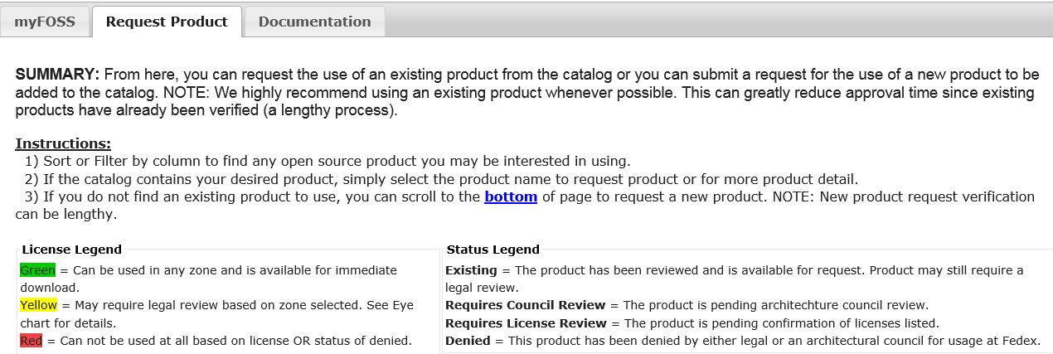

Here is the main page for looking to see if software is currently available, if it can be used at FedEx, or if you need to create a request for a new product.

The current software is color-coded which tells you immediately if it’s already been reviewed, if it is approved for certain zones, or denied usage at all.

Green - requests have already been through the process and approved and are available for all zones. See below for steps on how to request  
Yellow – a request must be made to find out if this is available dependent on your zones, etc. See below for steps on how to request.   
Red requests have been denied and cannot be used at FedEx

For Yellow and new requests, the FOSS EYECHART is your best source to know at a glance if the license is allowed dependent on your chosen zone; learn to use this as a help when applying for OSS. To understand zones better see descriptions in the Business Process Standards document.

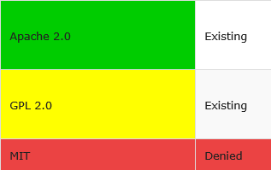

You can use the search bar to put in a search term to find open Source Products; NOTE this word may be in the software or description field. Filter on the description field if you are looking for software that does a certain action or supplies a certain result but don’t have a particular product in mind. You can sort by the Product Name column or use the filters given to narrow down your search.

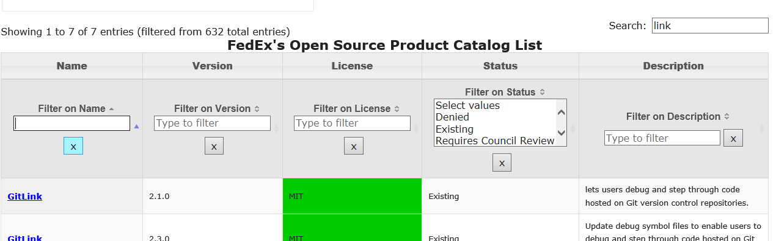

Sort name column alphabetically   
Clear filter choices

Filter on Name will show matches for full or partial characters in the software product name

Once you find the product you want, if it is GREEN or YELLOW click on the **product name link** to bring up a form to fill out for details on how and where it will be used and for what security zone. This is a requirement for all FOSS requests.

Be aware of the version you see here and the version you are needing; this **software is approved for the version seen here ONLY**. If you cannot use the version listed, you must request a new version of the software, which will have to go through the FOSS approval process. **We recommend you read the descriptions and use existing approved products if possible.**

All requests get evaluated - even those that are green – and if the form is filled out correctly and it agrees with the current standard for usage (eye chart) then you will get a link created on your myFOSS page. If there are zones or circumstances that need further review it will go to the Arch Council every Monday for evaluation and approval; sometimes the Arch Council requires more information so you or a representative must attend. Some requests are determined to need to have a Legal review done and they are passed onto that queue. Those requests that require Arch Council or Legal review are informed via email before and after the reviews.

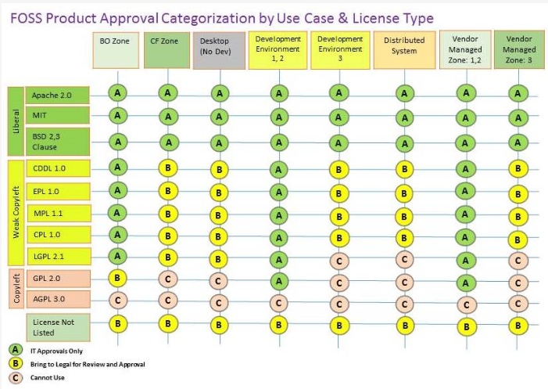

EYE CHART – Know your A-B-C’s!!

Approval is based on the license type and security zone, and specifics within the zone that you select; some licenses are approved across all zones (depending on evaluation of request), while others are dependent on zone, version, and other criteria.

Some licensed software is not allowed at FedEx (“C”) or is highly limited dependent on zone; other software within the product list might be found that offer the same function; searching the descriptions can help you find them.

A = IT approval only (Arch Council)

B = likely will need to go to Legal

C = not allowed at FedEx/cannot use

A detailed list for all zones and license types is found in the [**Business Process Standards**](https://esso.secure.fedex.com/pex/foss/bps.doc) document

If the software you choose will run in more than one zone – and the zones are not the same approval grade – then the ‘lowest’ set will apply for processing and approval track. For example: if you apply for both the Back Office (BO) zone and the Desktop zone for a CDDL 1.0 license, then the “B” rating would apply and the request would go to the Legal review route.

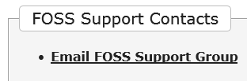

For help and direction on the site, the request form, and OSS software usage in FedEx, email the support group for help. Requests are usually responded to within 24 hours. Check out the FAQ section to see if your question can be answered there first.

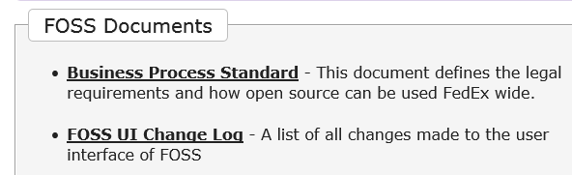

This document is a **mandatory read** in order to request any open source software and includes specific Legal acknowledgements for all users. This document also contains specific requirements related to source codes and licensing categorization.

Change log for updates to FOSS site

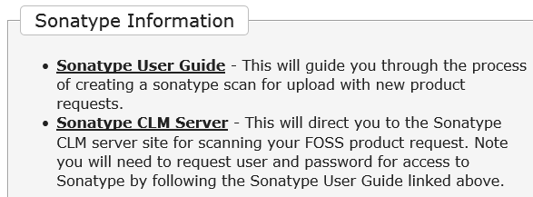

How-to document for how to scan the software to complete the OSS request. Access by association to organization is required via an email request. Additional documentation is found within this document to help with the CLM report.

Link for the database where you will upload your OSS product. NOTE to use the CLM Sonatype database, you must request access via the link in the Sonatype user guide first.

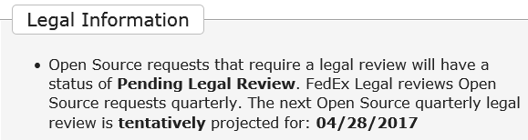

Certain software must go to Legal in order to be approved for usage; this meeting only occurs quarterly so these requests are held until they can be reviewed and either approved, sent back for more research, or denied. Due to time limitations Legal only reviews a set number each quarter so some requests must be rotated off for the next quarter. Be aware that all “B” requests on the eye chart may take a long while to get approved due to the Legal review process. This date changes quarterly.

**Creating a request for already approved – GREEN – software**

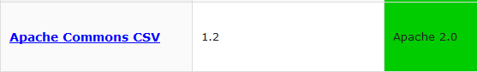

Even though software has been approved for all zones and is GREEN, you cannot automatically download it for usage; you are required to fill out a form before you are granted access.

Anyone downloading and using OpenSource software at FedEx is required to read and agree to **all aspects** within the [**Business Process Standard**](https://esso.secure.fedex.com/pex/foss/bps.doc) document, including already approved products. This includes all authorized users listed on the form.

All fields should be populated, the ones with Red asterisk are required.

Additional information can be found for each field while hovering over the field name.

No OSS software can be modified in any way from its original form; all software is to be used “as is.” Make sure the software you request/download will be sufficient for your needs.

If not used on a primary workstation, then the EAI application in which the software will interact should be listed.

Include those products that this software will interface with while running.

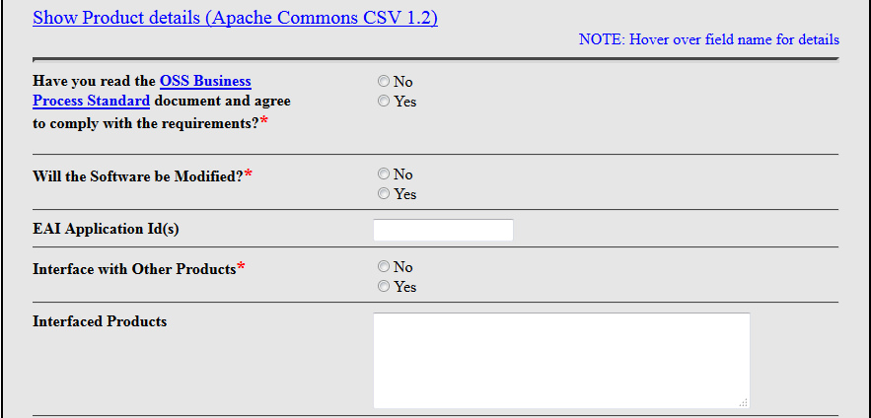

**Know your zone!**

Required field. More than one zone can be chosen, but the request will be assessed based on all zones.

Complete zone definitions are available in the Business Process Standard (BPS) document and should be **read before you complete your form.**

Incomplete zone entries or those that don’t align with the defined zone parameters will be rejected or asked for revisions before they can be processed.

Additional information on customer facing/back office/vendor managed security zones can be found here: [InfoSec EDC Security Zone white paper](https://esso.secure.fedex.com/infosec/edc/secure/SZ_Whitepaper1.1.PDF) (*for reference purposes only, published 2009)

Include the employee ID of anyone who will be using/downloading the software. Anyone listed here must also abide by the BPS document requirements and rules.

Free form fields:

Comment – any additional information you feel is pertinent for the EA team to know regarding this software or the use of it.

Maintenance/Support – once the application(s) are downloaded, who maintains and supports them and limits usage to those who were listed on the form?

**********************************************

Once your request is processed, you will **receive an email** with a link to your myFOSS page so you can download the software.

If additional information or clarification is needed in order to process your request, you’ll be emailed with specifics questions.

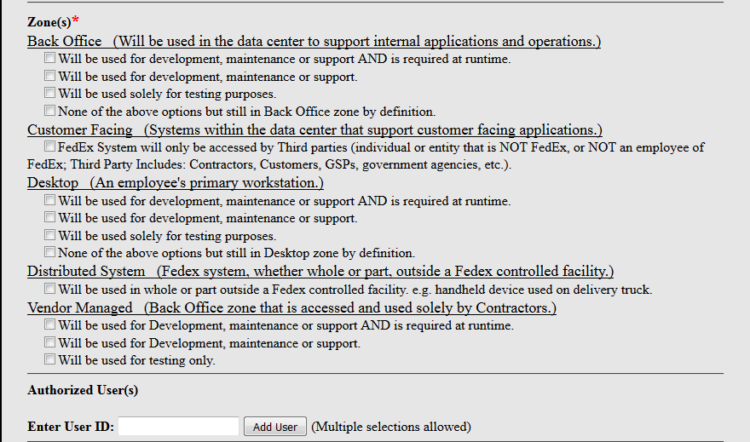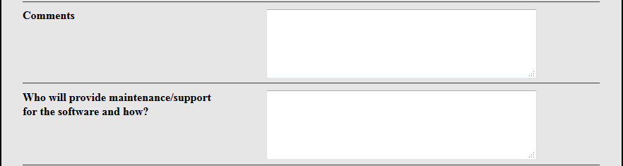

**Creating a Request for – YELLOW - software**

You must read and abide by the rules and regulations of the [**Business Process document**](https://esso.secure.fedex.com/pex/foss/bps.doc) – required.

The form and fields are identical as for the green software above; please read those field descriptions carefully. Clicking on the link for the software will bring up the form and all fields and data are the same, and all zone descriptions should be read and understood.

All forms are verified for accuracy before they go to the weekly Arch meeting. If additional information or clarification is needed in order to process your request, you’ll be emailed with specifics questions.

Unlike the green software that is approved for all zones, the yellow designates that it can only be used in specific zones and with specific licenses; see the **EYE CHART** for help assessing if the software you’re requesting is available in the zone in which it will be used. If this software will be used in multiple zones, then each should be listed on the form. See the EYE CHART above for clarification on zones and licenses.

If your software doesn’t require a Legal review, you will get an email with a link for uploading the software. All decisions are emailed to the requestor with the status of the request; complete status descriptions are available at the end of this document.

If your request does need to have a Legal review, please note that these reviews are only done quarterly and only a limited number are reviewed at a time so the queue is long and the wait can exceed months. We have no control over this process and cannot circumvent or change the time constraints nor move anyone up in the list; each request is added to the queue and reviewed in the order they’re received.

**Requesting NEW software**

New Open Source software requests can take a long time for approval. Each new request’s licensing is verified and then goes before the weekly Architecture Council for initial review.  Based on the licensing and use case some requests are approved at the Arch Council level while others require review by FedEx Legal to determine if it’s safe for use within FedEx. These Legal reviews are only done quarterly and only a limited number are reviewed at a time so the queue is long and the wait can exceed months.  Developer Services have no control over the Open Source review process and cannot circumvent or influence the time constraints nor move any requests up in the queue. Each request is added to the queue and reviewed based on age, number of requests, project priority, urgency, criticality, and/or Senior Leadership engagement.

Open Source software cannot be modified in any way from its original form; all software is to be distributed and used “as is.” Make sure the software requested/downloaded will be sufficient for your needs.

Requesting new software is a multi-step process and these steps are required before you start:

Read the Business Process Standard document – required. Anyone downloading and using OpenSource software at FedEx is required to read and agree to all aspects contained therein.  This includes licensing, license categories, security zones and development environments.

Read the Sonatype User Guide to understand the process for scanning software requests for licensing discovery.

Step 1: Get the software specifics ready to fill out the form (all Licenses, binary, URL, description, etc.)  
Step 2: Request access to the Sonatype CLM server; upload and Scan the software in Sonatype and save pdf doc  
Step 3: Open new request form to request new software, which will include attaching the CLM documentation (2 screens)

Once requests are submitted in FOSS, the licensing will be verified and put on the agenda for the next weekly Application Architecture Council (AAC) meeting.  A team member from the requesting group is required to attend the AAC represent their product request and to answer any questions.

A notification from FOSS is sent out to each requestor for that week informing them of their status and next steps.  See below for complete status and what they mean.

.

.

**Steps 1 & 2: Requesting New Software – Sonatype CLM Server -** Read the [**Sonatype User Guide**](https://collab.purplehub.fedex.com/Communities/EAA%20-%20Developer%20Services/Documents/FOSS%20Development%20Documentation/FedEx%20User%20Guide%20-Sonatype%20CLM%20App%20Scanning%20for%20Open%20Source_v1.1_031517%20(002).docx) for help creating process. Once you are granted access, you’ll add an application that you’ll then use to upload and evaluate the software. That pdf report is saved and used on the FOSS form.

**Step 3: Requesting New Software – Creating the FOSS request (2 screens)**

All fields with a Red asterisk are **required**

Product name should be in full as it appears on the product website

Be sure of the version requested meets all your needs as no software can be modified. Only this version will evaluated for approval

Description from the product website

Licenses are found in the product description – list all licenses

What hardware will this run on

What Platform is required

URL of product software or binary file

If this software is part of a DFA area in which the requesting group is a TFA Owner and if they will need to be involved in future approvals for use of this software within FedEx. See **FAQ** section for more.

Contacts who would be involved in this DFA and software pertaining to it.

Additional comments

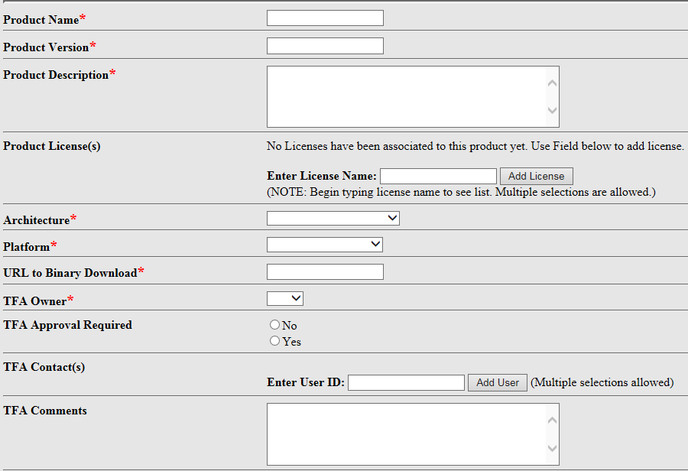

The executable package for the software product, found on the products website

The pdf file that you received/saved from the Sonatype binary scan/evaluation. See the [Sonatype User Guide](https://collab.purplehub.fedex.com/Communities/EAA%20-%20Developer%20Services/Documents/FOSS%20Development%20Documentation/FedEx%20User%20Guide%20-Sonatype%20CLM%20App%20Scanning%20for%20Open%20Source_v1.1_031517%20(002).docx) for more information

**NOTE**: this is the first screen of two – incomplete fields will **not allow you to proceed** to the second screen for completion of request

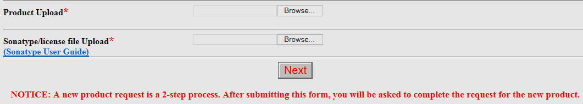

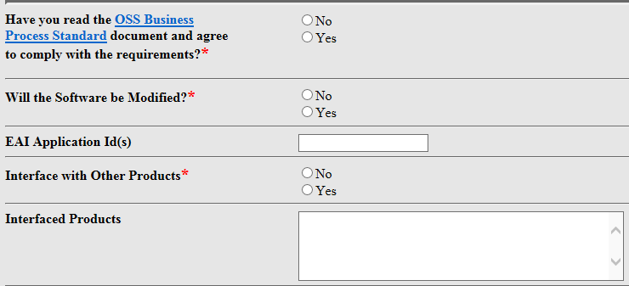

Anyone requesting and using OpenSource software at FedEx is required to read and agree to **all aspects** within the [**Business Process Standard**](https://esso.secure.fedex.com/pex/foss/bps.doc) document, including already approved products. This includes all authorized users listed on the form.

No OSS software can be modified in any way from its original form; all software is to be used “as is.” Make sure the software you request/download will be sufficient for your needs.

If not used on a primary workstation, then the EAI application in which the software will interact should be listed.

Include those products that this software will interface with while running.

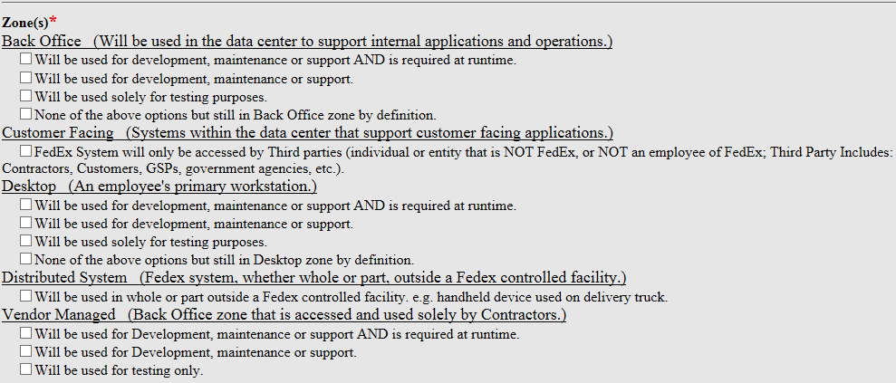

**Know your zone!**

Required field. More than one zone can be chosen, but the request will be assessed based on all zones.

Complete zone definitions are available in the Business Process Standard (BPS) document and should be **read before you complete your form.**

Incomplete zone entries or those that don’t align with the defined zone parameters will be rejected or asked for revisions before they can be processed.

Additional information on customer facing/back office/vendor managed security zones can be found here: [InfoSec EDC Security Zone white paper](https://esso.secure.fedex.com/infosec/edc/secure/SZ_Whitepaper1.1.PDF) (*for reference purposes only, published 2009)

Include the employee ID of anyone who will be using/downloading the software. Anyone listed here must also abide by the BPS document requirements and rules.

Free form fields:

Comment – any additional information you feel is pertinent for the EA team to know regarding this software or the use of it.

Maintenance/Support – once the application(s) are downloaded, who maintains and supports them and limits usage to those who were listed on the form?

**********************************************

Once your request is processed, you will **receive an email** about the Architectural Council meeting and who should attend. If approved at the AAC meeting, you’ll receive an email when you can download the software. If your software request must go onto Legal, then you’ll be added to the queue and get notification on that outcome. NOTE: this can be a long process.

If additional information or clarification is needed in order to process your request, you’ll be emailed with specifics questions.

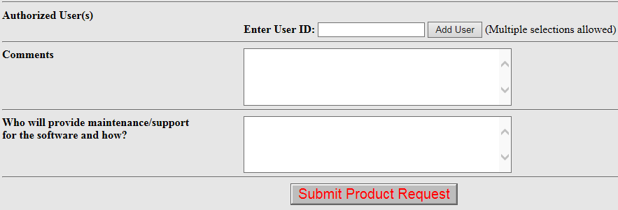

**Frequently Asked Questions – FAQ’s**

Can I modify the software once I download it?  
No OSS software can be modified from its original form; all OSS software code is approved “as is” and **should not be altered in any way**. If you find that the software is not what you want without coding changes then look for a different version that might have the component(s) you want.

What is the EAI number? I don’t have this  
The Enterprise Application Inventory application ID number that you tie the OSS product to and is tied to a project. If you don’t have an EAI # then you can create a “dummy” number to complete the form (your EmpID plus four digits e.g.6792303344).

TFA Owner:  I do not understand what a TFA owner is.  
Technical Focus Area (TFA) owner is the Director or ‘Director assigned representative’ who has responsibility for a Technology Focus Area.  If you were the TFA owner of an area, for example, Messaging, and you were looking at a new tool for the Enterprise Messaging queues, then you would fill out this area.You will put a TFA owner if the request is owned, managed and requires approval by a TFA owner.  If not, select “No” under **TFA Owner** and **TFA Approval Required**, and don’t add any names to the names box. For more information on the TFA Owner see [here](http://team.web.fedex.com/sites/EnterpriseArchitecture/ArchEngLeadership/GovernanceCompliance/Pages/TFAOwnersManualSummary.aspx)

Multiple users within my group need to have access to this software, can I include multiple people in the request?  
Access for download – upon approval – is granted to whomever is included as an Authorized User in the form. Remember that each person needs to read the Business Process Standard document and by clicking the YES any person listed on the form agrees to the Legal and FedEx standards.

Can the software run on more than one Zone? Can I choose more than one zone within one request form?  
You should choose all the zones in which you’ll download and use the software; all answers must be the same for all zones selected. Note that some zones and specific choices within the zones can impact how the request is processed and approved.

Why can’t I find any frameworks software on FOSS? -   
Framework applications like JQuery, JQuery ++, FuncUnit and DocumentJS are included in the **Modern Web**. The FedEx Modern Web Stack contains all frameworks.  To access Modern Web, please go to <http://modern.web.fedex.com/>.  For all the tools included in this stack, please see:  <http://modern.web.fedex.com/governance/modern-web-stack.html> (This site contains all the information needed to get started on a project and even includes links to previous training sessions that have been recorded. The "Getting Started" section will cover setup through the yeoman generators, which will generate everything needed to get started). **NOTE**: Some Modern Web applications might be included in FOSS for 2017; further details will be made available if/when this occurs

Why can’t I get Spring Frameworks through the FOSS site?  
Spring products are managed by the DevFramework team.  Access their site at keyword: **Maven**.  
NOTE: be aware that starting June 1, 2017 Development Framework will no longer provide Ant build scripts as part of the Development Framework examples.  The Development Framework will provide documentation or examples relating to Maven after the June 1, 2017 date.   
**2/2/17 New Framework Features and Upgrades Available in Version 7.1.0:  
 Production Nexus -**The Development Framework projects have been converted to production Nexus.  
 **CSR REST Capable -** CSR will have the capability to serve XML REST.   
 **CSR2 Token -** CSR2 will now require the token sent in the HTTP header “X-CSR-SECURITY_TOKEN” to be URL encoded.  
 **Apache HTTP Client -** CSR2 was modified to use the Apache HTTP Client for performance reasons.  
 **Logging -** Logging of certificate status was moved to a timer that runs based on the “security.api.token.expiration.check” security.properties property  
 **Upgrade to log4j 2.6.2 -** The FedEx Logger has been upgraded to use log4j 2.6.2.  This upgrade is to provide log4j2 defect fixes and new features including support for Java7.    
 **Upgrade of Spring Version to 4.3.2 -** Requires downloading of the framework bundle jars.  Only supports this bundle; any tampering for custom use is prohibited.

URL to Binary Download:  what exactly should I put here?  
This is where you will put the .exe, zip file, binary file, jar file or any other way to download and distribute the open source technology you are requesting.

I can’t supply the binary file/the file is too large – can I just put in the URL for the website?  
Yes, please include the URL of the download website to the binary file for the product.

Product Upload: is it sufficient to list the download website in the URL to Binary Download field?  
Yes, please include the download website to the binary file for the product. Be certain you include the complete/correct site as we will not go “find” it if you send a wrong product file.

Sonatype Scan: how do I do this?  
Click in the link for the Sonatype User Guide and follow the instructions to request access to the Sonatype CLM server; you must do this **first** before you can scan your software. **USE YOUR EmpID AS BOTH THE USERNAME AND LOGIN**-NO LDAP – you will get an “invalid credentials” if you do. Follow the instructions and scan your product request for license, policy and security validation.  Save your scan results from Sonatype **as a PDF file** and save it locally.  Upload this Sonatype scan of your product request in this field.

Sonatype says I cannot scan javascript files, only compiled files.  
Correct, javascript files cannot be scanned in Sonatype.  Put in the license file for your request.  We need evidence of a license to validate the open source request.

My software is C++ - can I scan it in Sonatype?  
If it is a C++ product, you will not be able to scan it. Upload the license file or provide a link for the license in that field.

I don’t have access to the software so can I upload the installer exe file?  
Yes, uploading the binary/jar file or the installer exe file is fine.

I don’t have / I don’t know how to add a “new application” for the software scan  
Click on the “Application Name” button and a new form comes up; add the app name and ID and save (leave the icon as default); this should be the application in which this software will run. If you do not have an associated EAI appID then you can put in a “dummy” app name and number to complete the scan. Make the number unique (i.e. not ‘123456’). Using your empID should work. If you’ve previously added an application using your EmpID then you’ll need to add a digit or two to it as no two numbers can be the same.

I put in a request for software but can’t download it immediately – why?  
All software requests have to be processed, reviewed and verified before you’ll see a download link on your myFOSS page – even if they’re GREEN. For YELLOW requests, – due to complexities within the form or if more than one zone will be used, or depending on the associated license. Some products have to be reviewed by the Arch council

I see the software I need listed but I need a different version, is this a new request? Yes, if you require a different version, then please submit a new request.  If the version you need is not in our system, then please follow step number 3 (under instructions) on the request page.

My request has to go to Legal for review but it has been a long time since I’ve heard anything  
The Legal review is only done quarterly so there is a time lag for these requests; the next review date is listed on the Documents tab/Legal. Legal **only reviews a limited number of requests per quarter** so new requests go to the “bottom of the list” and have to rotate up depending on how many are in the queue before it. Some requests can take many cycles before it’s their turn for review with the Legal team. These limitations are set by Legal and adhered to by the FOSS team; we cannot submit requests out-of-cycle nor circumvent this schedule. We suggest looking for an already-approved software if you cannot wait for the potentially long timeframe that new software may require.

My request was rejected – is there a way to get an exception or pass?  
Sometimes the request is rejected due to what is on the form itself; either information is missing or the fields have conflicts on what is being requested. In this case, the requestor is contacted via email from a FOSS team member to see if they work with them to get things aligned so the request can be submitted and processed.   
Sometimes a request has to go to the Application Architectural Council (AAC) which is held weekly on Mondays. The requester is invited to attend and is encouraged to do so or have a representative present to discuss the open source product request or answer any questions prior to approval. If they have questions or concerns that can’t be addressed at the meeting, then the request might be denied until it can be resubmitted with representation to the council for discussion.  
Some requests are not allowed due to license issues or there are components within the software itself which are not allowed at FedEx. **Any requests that have gone to Legal and were rejected are not allowed for use at FedEx.** Recommendation would be to find another software in the FOSS product line that can be used for your purposes or find a similar product online to submit for inclusion in the FOSS database.

Can I cancel my request and resubmit or modify it? I realized I checked a box that shouldn’t have been checked  
Yes, go ahead and cancel your request # and re-submit a new one with the correct information.

I think the product I want is commercial and not open source – can I still apply for it here?  
You must go through the Technology Evaluation process for commercial products.  Go to keyword ‘techeval; for instructions for that process

**Request Status (and what they mean):**

* **Approved** – Once a request is Approved for download
  + User can download via a link on their Platinum Exchange home page (keyword: **px**), or the download link on the ‘myFOSS’ tab in FOSS.  If the user has issues downloading please email FedExOpenSourceSupport.
* **Pending Product Verification** – User has requested a product that did not currently exist in the catalog
  + The reason for this status is: **This product needs to be reviewed to verify possible licenses. This is the initial step for New Products, once the licenses have been reviewed you will be notified.**
  + A FOSS Admin will review the Sonatype scan and product for licenses and assign accordingly.
* **Pending Council Review** – The product has been queued to be reviewed by the appropriate council
  + The reason for this status is: **This product needs to be reviewed by the council. You will be notified once a decision is made. If you are the first person to request this product, you will be notified directly to meet with the council.**
  + As the description states, the user will be notified when the council is ready to review the product requested.  Council meets weekly on Mondays.
* **Pending Legal Review** – The license(s) in product and zone(s) selected by requestor fall into a ‘B’ category
  + The reason for this status is: **Legal will review your request, you will be notified directly when your request is queued for the quarterly legal review. Once a decision is made, if there are comments they will be available in the Legal Comments on the Request Detail. This can be accessed by clicking on a FOSS ID on your 'myFOSS' tab.**
  + User will need to wait for the next quarterly review.  As the description states they will be notified when the request is queue for review.
* **Pending TFA Review** – This product belongs to a specific TFA that has specified all requests must go through the TFA for review
  + The reason for this status is: **The TFA for this product will need to review your request. Please see TFA Contacts regarding TFA Review. This can be accessed by clicking on a FOSS ID on your 'myFOSS' tab, then clicking the 'Show Product Details' link next to the Selected Product in your request**
  + With the new TFA Admin view, the TFA should be checking for requests pending their approval on a regular basis.  However, if the TFA has not made a decision after some time the user can always contact the TFA Owners.
* **Pending Interface Verification** – User has marked that the software will interface with other systems or software
  + The reason for this status is: **The interfacing product(s) need to be reviewed for this request.**
  + A FOSS Admin will review the interfacing systems or software and contact the requestor if further information is required.  Upon review, an appropriate status will be given to the request.
* **Denied** – User marked ‘Yes’ to ‘Will the Software be Modified?’
  + The reason for this status is: **Open Source products are not allowed to be modified. Please see definition of 'Modify' in the BPS Document.** [**Read it now**](https://collab.purplehub.fedex.com/Communities/EAA%20-%20Developer%20Services/Documents/FOSS%20Automation%20Docs/YLEGALDOCS-500449-v9-Open_Source_Code_Policy_Business_Process_Standard.doc)**, or find it on the 'Documentation' tab. If you do not have permission to view this document please contact FOSS Support.**
  + User needs to read the BPS and clarify if they will truly modify the software.  The request must be re-submitted.
* **Denied** – User selected a **zone that is not allowed**, per license(s) of product.
  + The reason for this status is: **Your request is denied based on the licenses contained in the product and the zone(s) you selected. For clarification of 'Zone' please review the BPS.** [**Read it now**](https://collab.purplehub.fedex.com/Communities/EAA%20-%20Developer%20Services/Documents/FOSS%20Automation%20Docs/YLEGALDOCS-500449-v9-Open_Source_Code_Policy_Business_Process_Standard.doc)**, or find it on the 'Documentation' tab. If you do not have permission to view this document please email** FedExOpenSourceSupport.
  + User may not fully understand which zone they will actually be using the software.  Review the BPS and contact FOSS Support to clarify.  If an incorrect zone was selected, a FOSS Admin can correct and the system will re-evaluate the request.  (Note: FOSS Admins can only modify the Zone(s) field once a request is submitted.  Users can only modify the ‘Authorized Users’ field once a request is submitted.  If any other fields are marked incorrectly, the user needs to cancel their request and submit the request again.)
* **Denied** – TFA has denied the request
  + The reason for this status is: **The TFA for this product has denied this request.** Please see any additional comments that were added for this product.
* **Denied** – Legal has denied the request
  + The reason for this status is: **Legal has denied this request.** If there are comments, please see the Legal Comments on the Request Detail. This can be accessed by clicking on a FOSS ID on your 'myFOSS' tab.